Civil war in Sierra Leone

UNSC Resolution: | 1270
Date of adoption: | 22 October 1999
Operative paragraph: | 2
Demand number: | 1

Megan MacKenzie

Wording of demand

fulfil their commitments under the Peace Agreement to facilitate the restoration of peace, stability, national reconciliation and development in Sierra Leone

List of addressees of the demand

Government of Sierra Leone, Armed Forces Revolutionary Council, Civil Defence Forces , Revolutionary United Front

Short-term compliance

Description of the addressee(s)’ conduct

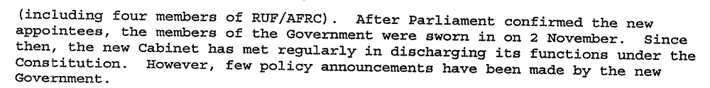
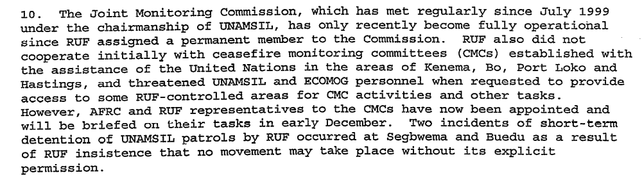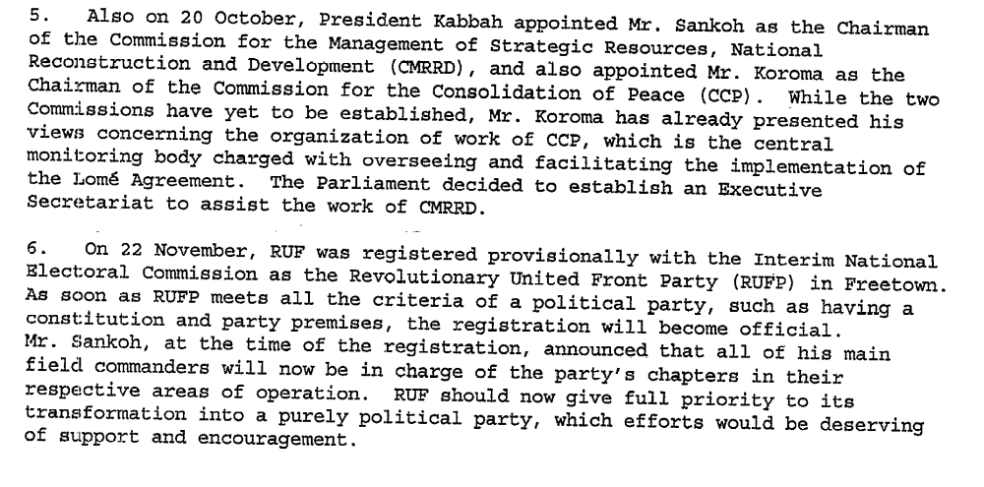

Assessment

Short-term compliance
No or marginal compliance (1) | x Medium low compliance (2) | Medium high compliance (3) | Full or almost full compliance (4)

Considerations underlying the assessment

There were marginal efforts by the parties to fulfill their commitments under the Peace Agreement and to facilitate the restoration of peace- notably, the integration of the RUF into the government. Overall there remained resistance to implement the process, particularly by the RUF.

Medium-term compliance

Description of the addressee(s)’ conduct

Abidjan’s timetables were not met. Instead, Sierra Leone experienced further turmoil and conflict, demonstrating the country’s rebel factions were not committed to peace.

Assessment

Medium-term compliance
x No or marginal compliance (1) | Medium low compliance (2) | Medium high compliance (3) | Full or almost full compliance (4)

Considerations underlying the assessment

Over the long term, the primary tenants of the Peace Accord were not complied with. Hostilities continued during this period, UN peacekeepers were captured and injured, and the disarmament process was halted for a period of time.

Depth of demand

Assessment

Level of depth of demand
Low depth of demand (1) | Medium depth of demand (2) | x High depth of demand (3)

Considerations underlying the assessment

The Peace Agreement contained numerous stipulations that required the parties to alter their behaviors drastically. Most importantly, it required a sustained ceasefire and the disarmament of the fighting factions. For the parties, this meant giving up a substantial amount of power that had been gained by carrying arms.

Level of confidence about coding decisions

Level of confidence about coding decision
Extremely high | x High | Moderate

Comments to IPI (if any)

Civil war in Sierra Leone

UNSC Resolution: | 1270
Date of adoption: | 22 October 1999
Operative paragraph: | 3
Demand number: | 1

Megan MacKenzie

Wording of demand

make every effort to ensure that all designated centres [disarmament, demobilization and reintegration] begin to function as soon as possible

List of addressees of the demand

Government of Sierra Leone

Short-term compliance

Description of the addressee(s)’ conduct

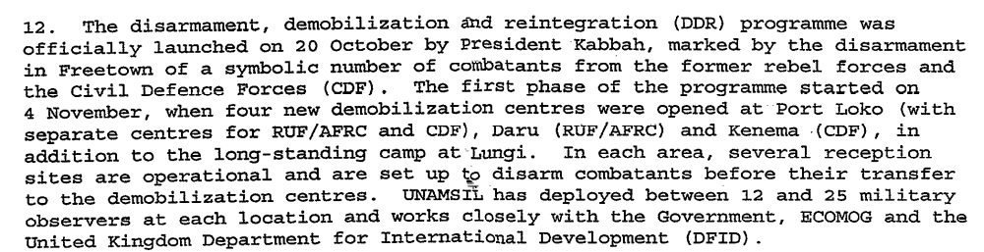
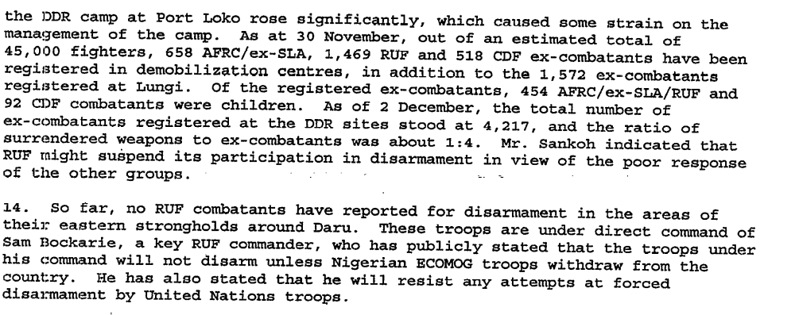

Assessment

Short-term compliance
No or marginal compliance (1) | Medium low compliance (2) | x Medium high compliance (3) | Full or almost full compliance (4)

Considerations underlying the assessment

Although there were some disturbances and continued hostilities during this period, the demand merely asks for the establishment and functioning of the disarmament facilities. By all accounts it appears that disarmament facilities were established and functioning during this period.

Medium-term compliance

Description of the addressee(s)’ conduct

A Joint Committee on DDR (GOSL/RUF/UNAMSIL) was set up at the initiation of ECOWAS/Government/ UN after ABUJA II in May 2001 to agree on modalities for the re-launching of DDR for all the factions. The Committee also provided the environment to address the political concerns of the fighting forces in order to gain their co-operation in the DDR process.
The first meeting of the committee was convened on 15 May 2001 in Freetown under the auspices of UNAMSIL. Thereafter, Phase III of the DDR was launched on May 18th 2001 with the commencement of disarmament in the Port Loko and Kambia Districts. Subsequently, it was agreed that given the need to build confidence with the fighting forces as well as to allow for time needed to mobilise and deploy United Nations Peacekeeping forces, the DDR programme would be implemented simultaneously in two districts a month, over a six month period.
Over the last eight months, and in collaboration with our key implementing partners (UNAMSIL, UNICEF, WFP, DFID, CPAs), NCDDR has been able to manage four operational elements simultaneously. This consists of disarmament and demobilisation of 47,766 combatants, payment of reinsertion benefits to 44,160 of the 49,732 registered and developing Opportunities for over 17,000 of the 28,000 who have registered with us.

Phase II of the programme was reactivated and implemented within the framework of the Lome Peace Agreement from October 1999. The process of disarmament and demobilisation commenced with the active participation of the International community and support of the various stakeholders. However, the programme was halted in May 2000 by the outbreak of hostilities among the fighting forces. This situation continued until two ceasefire agreements were negotiated a year later.
In June 2000, all stakeholders to the Peace Process (Government, UNAMSIL, Donors, Civil Society, NGOs, and Ex-Combatants) were brought together in a Consultative Meeting to review the DDR and agree on an acceptable way forward. This was followed by a comprehensive technical review of the programme in November 2000 for the benefit of Government, UN, Donors and the domestic and international Community at large.

Assessment

Medium-term compliance
No or marginal compliance (1) | x Medium low compliance (2) | Medium high compliance (3) | Full or almost full compliance (4)

Considerations underlying the assessment

The disarmament process came to a halt and then was re-initiated during this period. Although a significant number of militants were disarmed during this period, this brief cessation of the process implies that the centers were not functioning.

Depth of demand

Assessment

Level of depth of demand
Low depth of demand (1) | x Medium depth of demand (2) | High depth of demand (3)

Considerations underlying the assessment
This is a medium depth demand because it requires the establishment and functioning of the centers but does not specify disarmament or participation in the process. It is far easier to ensure centers are functioning than it is to ensure that members of armed factions are participating in the DDR process.

Level of confidence about coding decisions

Level of confidence about coding decision
Extremely high | High | x Moderate

Comments to IPI (if any)
I thought about choosing medium high for the compliance for the medium term. I was not sure how to factor in the period of time in which the DDR was stopped. I assume this should be factored into the assessment even though in the longer term the DDR was quite successful.

Civil war in Sierra Leone

UNSC Resolution: | 1270
Date of adoption: | 22 October 1999
Operative paragraph: | 4
Demand number: | 1270.0411

Megan MacKenzie

Wording of demand

begin immediately to disband and give up their arms in accordance with the provisions of the Peace Agremeent, and participate fully in the disarmament, demobilization and reintegration programme

List of addressees of the demand

Government of Sierra Leone, Armed Forces Revolutionary Council, Civil Defence Forces , Revolutionary United Front

Short-term compliance

Description of the addressee(s)’ conduct

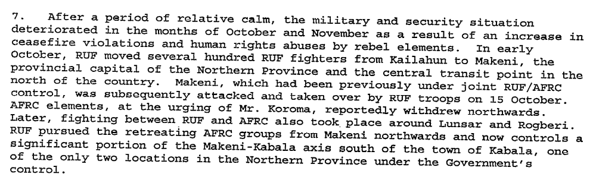
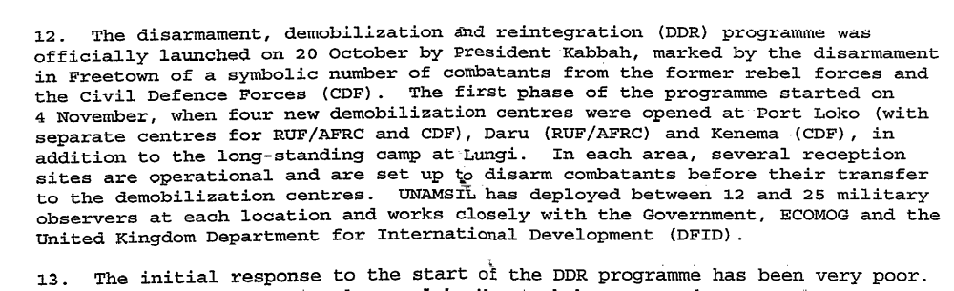

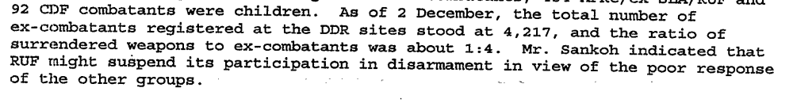
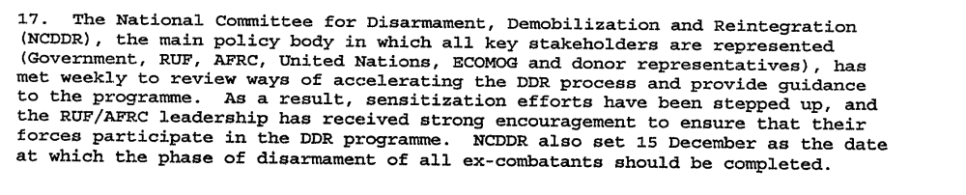

Assessment

Short-term compliance
No or marginal compliance (1) | x Medium low compliance (2) | Medium high compliance (3) | Full or almost full compliance (4)

Considerations underlying the assessment

There was marginal participation in the DDR process; however it is clear that the fighting forces did not fully disband or wholeheartedly participate in the disarmament process.

Medium-term compliance

Description of the addressee(s)’ conduct

Of course, no disarmament process can expect to get all the weapons, but the process in Sierra Leone has been particularly poor, and few observers doubt that RUF commanders are holding back caches. On the surface, significant strides appear to have been made in the disarmament process. About 22,000 combatants have disarmed since the DDR program resumed in May 2001, over a third of the estimated total.

Since the May 2002 elections the former rebel group turned political party, the Revolutionary United Front Party (RUF-P), has suffered more divisions and lost much of what little support it had prior to entering the political contest. It has poor prospects for survival, particularly after the indictment of four of its top leaders by the Special Court. As a fighting force, the RUF is obsolete.

Assessment

Medium-term compliance
No or marginal compliance (1) | x Medium low compliance (2) | Medium high compliance (3) | Full or almost full compliance (4)

Considerations underlying the assessment

The disarmament process was fraught with set-backs and poor participation during this period. Parties did comply partially with this demand.

Depth of demand

Assessment

Level of depth of demand
Low depth of demand (1) | Medium depth of demand (2) | x High depth of demand (3)

Considerations underlying the assessment
Disarming and encouraging rebel troops to disarm required a marked change in behavior for the rebels. In many ways, disarming implied changing the mission, organization and purpose of the rebel forces.

Level of confidence about coding decisions

Level of confidence about coding decision
Extremely high | High | x Moderate

Comments to IPI (if any)

Civil war in Sierra Leone

UNSC Resolution: | 1270
Date of adoption: | 22 October 1999
Operative paragraph: | 5
Demand number: | 1

Megan MacKenzie

Wording of demand

engage fully and responsibly in the implementation of the Peace Agreement and direct the participation of all rebel groups in the disarmament and demobilization process without delay

List of addressees of the demand

Revolutionary United Front , Armed Forces Revolutionary Council

Short-term compliance

Description of the addressee(s)’ conduct

In January 2000 Foday Sankoh “told a gathering of his RUF fighters [in English]….to cooperate with the disarmament process” in front of UN staff. Later he told them in Temne and Mende not to disarm.

Assessment

Short-term compliance
x No or marginal compliance (1) | Medium low compliance (2) | Medium high compliance (3) | Full or almost full compliance (4)

Considerations underlying the assessment

The demand specifically encourages parties to “direct the participation of all rebel groups in the disarmament and demobilization process without delay,” yet there is indication that RUF commanders were encouraging their troops not to disarm.

Medium-term compliance

Description of the addressee(s)’ conduct

Of course, no disarmament process can expect to get all the weapons, but the process in Sierra Leone has been particularly poor, and few observers doubt that RUF commanders are holding back caches. On the surface, significant strides appear to have been made in the disarmament process. About 22,000 combatants have disarmed since the DDR program resumed in May 2001, over a third of the estimated total.

Since the May 2002 elections the former rebel group turned political party, the Revolutionary United Front Party (RUF-P), has suffered more divisions and lost much of what little support it had prior to entering the political contest. It has poor prospects for survival, particularly after the indictment of four of its top leaders by the Special Court. As a fighting force, the RUF is obsolete,

Assessment

Medium-term compliance
No or marginal compliance (1) | x Medium low compliance (2) | Medium high compliance (3) | Full or almost full compliance (4)

Considerations underlying the assessment

There is evidence that the parties worked towards fulfilling this demand; however, hostilities continued during this extended period.

Depth of demand

Assessment

Level of depth of demand
Low depth of demand (1) | Medium depth of demand (2) | x High depth of demand (3)

Considerations underlying the assessment
Disarming and adhering to the peace agreement required the parties to alter their behavior significantly and to relinquish power.

Level of confidence about coding decisions

Level of confidence about coding decision
Extremely high | High | x Moderate

Comments to IPI (if any)

Civil war in Sierra Leone

UNSC Resolution: | 1270
Date of adoption: | 22 October 1999
Operative paragraph: | 6
Demand number: | 1

Megan MacKenzie

Wording of demand

put an end to such practices [taking of hostages, including UNOMSIL and ECOMOG personnel, by rebel groups] immediately and address their concerns about the terms of the Peace Agreement peacefully through dialogue with the parties concerned

List of addressees of the demand

Revolutionary United Front , Armed Forces Revolutionary Council

Short-term compliance

Description of the addressee(s)’ conduct

Assessment
There is indication that there was hostility towards peacekeeping forces during this period.

Short-term compliance
x No or marginal compliance (1) | Medium low compliance (2) | Medium high compliance (3) | Full or almost full compliance (4)

Considerations underlying the assessment

Medium-term compliance

Description of the addressee(s)’ conduct
Heavily armed rebels continued to seize U.N. troops in Sierra Leone Thursday, bringing the total number of hostages to at least 69, including a British officer and a Russian helicopter crew as well as Indian and Kenyan peacekeepers, U.N. officials said.

Liberian and United Nations officials said today that they believed that Sierra Leone rebels had released the remaining hostages among some 500 United Nations personnel captured earlier this month.

Assessment

Medium-term compliance
x No or marginal compliance (1) | Medium low compliance (2) | Medium high compliance (3) | Full or almost full compliance (4)

Considerations underlying the assessment
This demand was clearly violated as a result of direct hostilities towards peacekeepers.

Depth of demand

Assessment

Level of depth of demand
Low depth of demand (1) | x Medium depth of demand (2) | High depth of demand (3)

Considerations underlying the assessment
Respecting peacekeeping staff required the parties to relinquish some power and authority in the country.

Level of confidence about coding decisions

Level of confidence about coding decision
Extremely high | High | x Moderate

Comments to IPI (if any)

Civil war in Sierra Leone

UNSC Resolution: | 1270
Date of adoption: | 22 October 1999
Operative paragraph: | 13
Demand number: | 2

Megan MacKenzie

Wording of demand

respect fully the status of United Nations and associated personnel

List of addressees of the demand

Government of Sierra Leone, Armed Forces Revolutionary Council, Civil Defence Forces , Revolutionary United Front

Short-term compliance

Description of the addressee(s)’ conduct

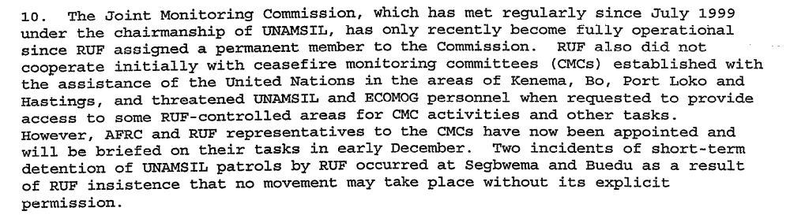

Assessment

Short-term compliance
x No or marginal compliance (1) | Medium low compliance (2) | Medium high compliance (3) | Full or almost full compliance (4)

Considerations underlying the assessment

During this period the RUF were the primary violators of this demand. They did not respect the status of UN personnel. They inhibited the movement of UN peacekeepers and thereby limited the effectiveness of the mission.

Medium-term compliance

Description of the addressee(s)’ conduct

The Lomé agreement collapsed in May 2000. The RUF was chiefly to blame,
sabotaging the peace process by capturing 500 UN peacekeepers and their
equipment.

May 2000 RUF rebels took over 400 UN peacekeepers hostage.

Assessment

Medium-term compliance
x No or marginal compliance (1) | Medium low compliance (2) | Medium high compliance (3) | Full or almost full compliance (4)

Considerations underlying the assessment
This is perhaps one of the most clear cut assessments. The rebel forces kidnapped UN peacekeeping staff and a significant round of negotiations were necessary to secure their return. UN staff were injured and the overall integrity of the mission was threatened by rebel forces.

Depth of demand

Assessment

Level of depth of demand
Low depth of demand (1) | x Medium depth of demand (2) | High depth of demand (3)

Considerations underlying the assessment
Respecting the UN mission required that the parties relinquish a certain amount of power and control over territory. It did not require them to change their behavior completely but it did assume certain alterations to their activities to ensure the secure operation of the mission.

Level of confidence about coding decisions

Level of confidence about coding decision
Extremely high | x High | Moderate

Comments to IPI (if any)

Civil war in Sierra Leone

UNSC Resolution: | 1270
Date of adoption: | 22 October 1999
Operative paragraph: | 16
Demand number: | 1

Megan MacKenzie

Wording of demand

conclude a status-of-forces agreement with the Secretary-General within 30 days of the adoption of this resolution

List of addressees of the demand
Government of Sierra Leone

Short-term compliance

Description of the addressee(s)’ conduct
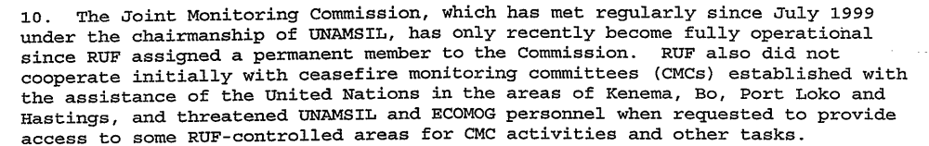

Assessment

Short-term compliance
No or marginal compliance (1) | Medium low compliance (2) | Medium high compliance (3) | Full or almost full compliance (4)

Considerations underlying the assessment
I could not find any research directly referencing a status of forces agreement; therefore, I did not code this demand.

Medium-term compliance

Description of the addressee(s)’ conduct

Assessment

Medium-term compliance
No or marginal compliance (1) | Medium low compliance (2) | Medium high compliance (3) | Full or almost full compliance (4)

Considerations underlying the assessment

Depth of demand

Assessment

Level of depth of demand
Low depth of demand (1) | Medium depth of demand (2) | High depth of demand (3)

Considerations underlying the assessment

Level of confidence about coding decisions

Level of confidence about coding decision
Extremely high | High | Moderate

Comments to IPI (if any)
I could not find any references to this status of forces agreement so I did not code this demand.

Civil war in Sierra Leone

UNSC Resolution: | 1270
Date of adoption: | 22 October 1999
Operative paragraph: | 17
Demand number: | 1

Megan MacKenzie

Wording of demand

promote peace and national reconciliation and foster accountability and respect for human rights in Sierra Leone and ensure the prompt establishment and effective functioning of these bodies [Truth and Reconciliation and Human Rights Commission] with the full participation of all parties and drawing on the relevant experience and support of Member States, specialized bodies, other multilateral organizations and civil society

List of addressees of the demand

Government of Sierra Leone

Short-term compliance

Description of the addressee(s)’ conduct

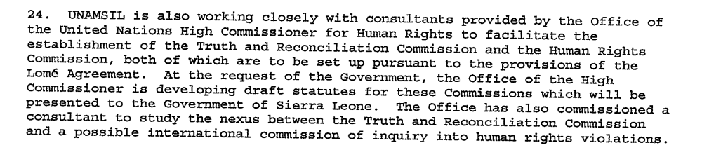

Assessment

Short-term compliance
No or marginal compliance (1) | Medium low compliance (2) | x Medium high compliance (3) | Full or almost full compliance (4)

Considerations underlying the assessment

This demand was not fully complied with but there is evidence that the Government of Sierra Leone made a significant effort to promote peace and national reconciliation and to establish the Human Rights and Truth and Reconciliation Commission.

Medium-term compliance

Description of the addressee(s)’ conduct
The collapse of the Lome Agreement in May 2000 delayed the establishment of the SLTRC for two years. An interim secretariat was finally named in March 2002, and the commission’s official inauguration took place in July.
… the Human Rights Commission of Sierra Leone (HRCSL) was established as an independent national human rights institution by the Human Rights Commission of Sierra Leone Act No.9 of 2004 as provided in the Lome Peace Accord of 1999, and the recommendations of the Truth and Reconciliation Commission (TRC) report

Assessment

Medium-term compliance
No or marginal compliance (1) | x Medium low compliance (2) | Medium high compliance (3) | Full or almost full compliance (4)

Considerations underlying the assessment
The demand specifically asks for the prompt establishment of the two commissions; however neither were established for several years. There were serious delays establishing the TRC and the Human Rights Commission was not established until 2004. This can hardly be called prompt; although it is clear that there were efforts being made shortly after the demand was issued.

Depth of demand

Assessment

Level of depth of demand
Low depth of demand (1) | x Medium depth of demand (2) | High depth of demand (3)

Considerations underlying the assessment

These commissions required a great deal of coordination, expertise and resources- none of which were in abundance when this demand was issued. Therefore, a substantial effort was necessary for the parties to comply with the demand.

Level of confidence about coding decisions

Level of confidence about coding decision
Extremely high | x High | Moderate

Comments to IPI (if any)

Civil war in Sierra Leone

UNSC Resolution: | 1270
Date of adoption: | 22 October 1999
Operative paragraph: | 18
Demand number: | 2

Megan MacKenzie

Wording of demand

address the special needs of all children affected by the conflict

List of addressees of the demand

Government of Sierra Leone

Short-term compliance

Description of the addressee(s)’ conduct

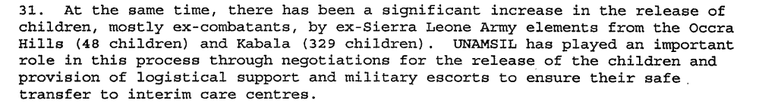

Assessment

Short-term compliance
No or marginal compliance (1) | x Medium low compliance (2) | Medium high compliance (3) | Full or almost full compliance (4)

Considerations underlying the assessment

It was likely difficult to establish mechanisms to address the needs of children during this chaotic time and there was not a great deal of research indicating an effort to address the needs of children during war at this time. A notable effort was the encouragement of children to disarm.

Medium-term compliance

Description of the addressee(s)’ conduct

19 May 2000
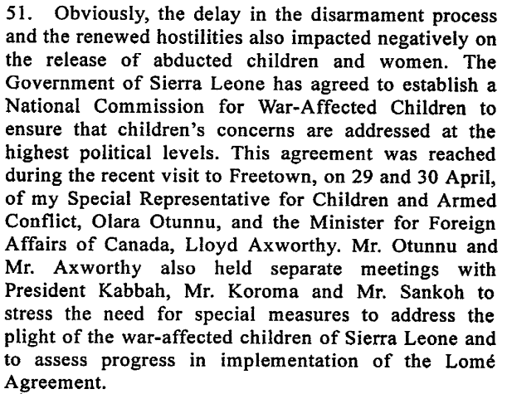

Following the massive and heinous atrocities of the war, especially on children in Sierra Leone, The Former President, His Excellency, Alhaji Dr. Ahmad Tejan Kabbah, in consultation with the UN Secretary General’s Representative for Children and Armed Conflict, saw the need to create a National Commission for War Affected Children. NaCWAC was established by an act of parliament in January 2001, and formally inaugurated by H.E. the President in February 2003. The inauguration was witnessed by the UN Secretary General's special representative for Children and Armed Conflict - H.E. Olara Otunu.

Assessment

Medium-term compliance
No or marginal compliance (1) | Medium low compliance (2) | x Medium high compliance (3) | Full or almost full compliance (4)

Considerations underlying the assessment

The international community put a significant amount of pressure on the Government of Sierra Leone to address the needs of children during this time and they responded well. The establishment of NAC WAC was seen as a major accomplishment and the Government cooperated with the UN special representative.

Depth of demand

Assessment

Level of depth of demand
x Low depth of demand (1) | Medium depth of demand (2) | High depth of demand (3)

Considerations underlying the assessment

Although addressing the needs of children required resources that were scarce during this time, it was in the interests of the Government to do so. Child soldiers had become a major focus of the international community- particularly Canada- and so resources were given to the Government of Sierra Leone to help them create programs for children.

Level of confidence about coding decisions

Level of confidence about coding decision
Extremely high | x High | Moderate

Comments to IPI (if any)

Civil war in Sierra Leone

UNSC Resolution: | 1270
Date of adoption: | 22 October 1999
Operative paragraph: | 19
Demand number: | 1

Megan MacKenzie

Wording of demand

ensure that refugees and internally displaced persons are protected and are enabled to return voluntarily and in safety to their homes

List of addressees of the demand

Government of Sierra Leone, Armed Forces Revolutionary Council, Civil Defence Forces , Revolutionary United Front

Short-term compliance

Description of the addressee(s)’ conduct

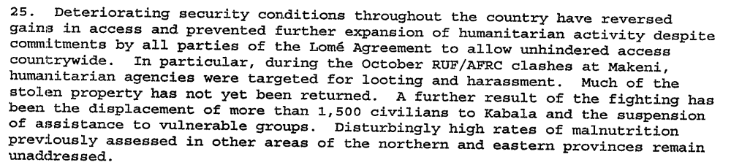
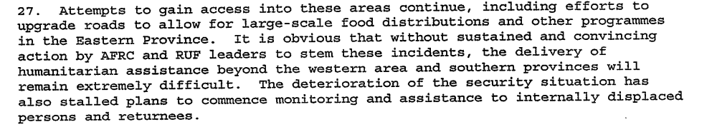

Assessment

Short-term compliance
x No or marginal compliance (1) | Medium low compliance (2) | Medium high compliance (3) | Full or almost full compliance (4)

Considerations underlying the assessment
Not only were refugees prevented from returning home, efforts to ensure their safety and even to monitor refugees and internally displaced persons were obstructed by rebel activity.

Medium-term compliance

Description of the addressee(s)’ conduct
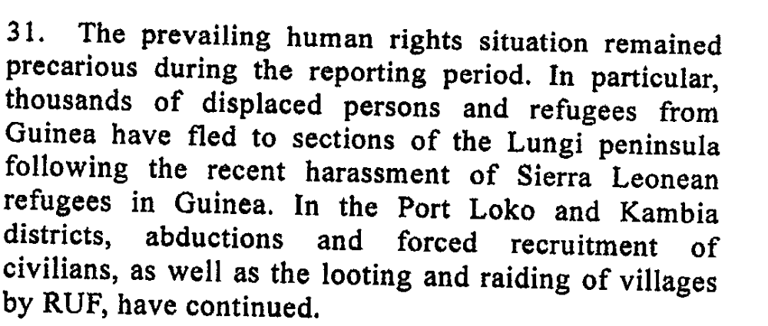
11. At the same time, UNHCR is facilitating the
voluntary repatriation to Sierra Leone of those who
wish to return. For the time being, the repatriation from
Guinea to Sierra Leone is organized by boat from
Conakry to Freetown, where reception facilities are
available.
12. A large majority of refugees come from areas
which remain under the control of RUF and which
therefore cannot yet be deemed safe for the purpose of
13. With the deterioration of the situation in Guinea
and Liberia and the gradual improvement of the overall
security situation in Sierra Leone, Sierra Leonean
refugees have begun to make their way back to Sierra
Leone spontaneously. Since September 2000, more
than 55,000 Sierra Leoneans have returned from
Guinea. About 35,000 of these have returned by boat
from Conakry since December 2000, with the
assistance of the International Organization for
Migration. The remainder returned spontaneously on
foot through Kambia, Kabala, Kono district, Kailahun,
Daru and Kenema. A significant number are believed
to have returned to places in the areas under RUF
control. In addition, refugees from Liberia have
returned to Sierra Leone at border crossings near

Assessment

Medium-term compliance
No or marginal compliance (1) | x Medium low compliance (2) | Medium high compliance (3) | Full or almost full compliance (4)

Considerations underlying the assessment
Refugees and internally displaced persons were returning home during this period but it seems that this is in spite of rebel activity not because of their participation.

Depth of demand

Assessment

Level of depth of demand
Low depth of demand (1) | x Medium depth of demand (2) | High depth of demand (3)

Considerations underlying the assessment

Ensuring the safety of internally displaced persons and facilitating their return required the parties to limit their fighting and consider the human rights situation of civilians. This is something that the factions did not seem to be doing during this period of time.

Level of confidence about coding decisions

Level of confidence about coding decision
Extremely high | x High | Moderate

Comments to IPI (if any)

Civil war in Sierra Leone

UNSC Resolution: | 1270
Date of adoption: | 22 October 1999
Operative paragraph: | 22
Demand number: | 2

Megan MacKenzie

Wording of demand

ensure safe and unhindered access of humanitarian assistance to those in need in Sierra Leone, guarantee the safety and security of humanitarian personnel and respect strictly the relevant provisions of international humanitarian and human rights law

List of addressees of the demand

Government of Sierra Leone, Armed Forces Revolutionary Council, Civil Defence Forces, Revolutionary United Front

Short-term compliance

Description of the addressee(s)’ conduct

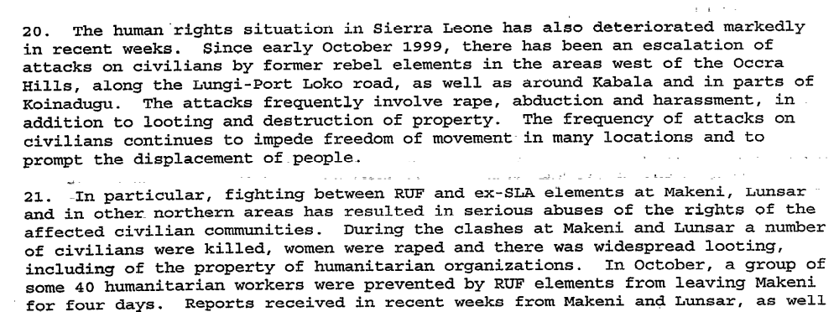

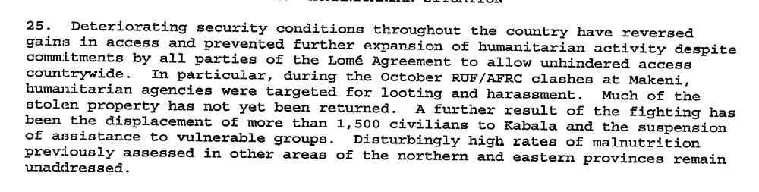

Assessment

Short-term compliance
x No or marginal compliance (1) | Medium low compliance (2) | Medium high compliance (3) | Full or almost full compliance (4)

Considerations underlying the assessment

There is clear indication from the Secretary General’s reports that there were human rights abuses and violations of international law. The reports specify that de to violence and insecurity, humanitarian assistance was hindered.

Medium-term compliance

Description of the addressee(s)’ conduct

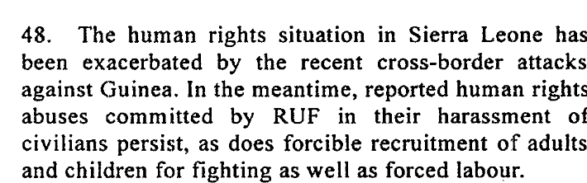
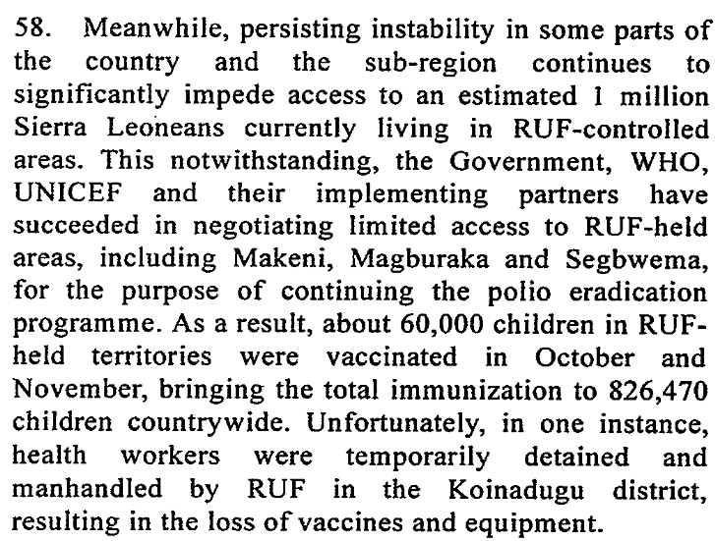

40. Investigations conducted by the Human Rights Section of UNAMSIL during the reporting period revealed attacks against the civilian population by both RUF and the Civil Defence Forces in several villages in the Kono and Koinadugu districts. On 17 June 2001, a CDF group attacked the village of Yaraiya. Corroborating witness accounts revealed that 24 people were killed in the attack. Following that incident, RUF combatants attacked the village of Henekuma on 19 July, killing at least 19 people. The RUF leadership attributed this attack to an unauthorized act by a renegade commander, and undertook to apprehend him.

Assessment

Medium-term compliance
x No or marginal compliance (1) | Medium low compliance (2) | Medium high compliance (3) | Full or almost full compliance (4)

Considerations underlying the assessment

There were clear human rights abuses and violations of international law by several of the parties addressed in this demand.

Depth of demand

Assessment

Level of depth of demand
Low depth of demand (1) | Medium depth of demand (2) | x High depth of demand (3)

Considerations underlying the assessment
This was a period characterized by chaos, violence and human rights abuses. By asking the parties to respect human rights and international law as well as facilitating humanitarian access, the UN was demanding that the parties alter their behavior substantially.

Level of confidence about coding decisions

Level of confidence about coding decision
x Extremely high | High | Moderate

Comments to IPI (if any)

Civil war in Sierra Leone

UNSC Resolution: | 1270
Date of adoption: | 22 October 1999
Operative paragraph: | 23
Demand number: | 1

Megan MacKenzie

Wording of demand

expedite the formation of professional and accountable national police and armed forces, including through their restructuring and training, without which it will not be possible to achieve long-term stability, national reconciliation and the reconstruction of the country

List of addressees of the demand

Government of Sierra Leone

Short-term compliance

Description of the addressee(s)’ conduct

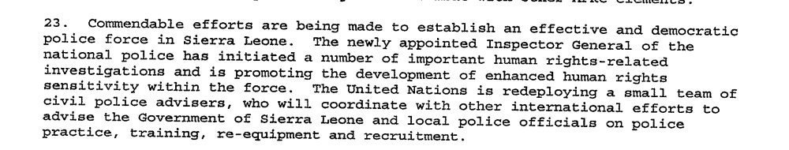

Assessment

Short-term compliance
No or marginal compliance (1) | Medium low compliance (2) | Medium high compliance (3) | x Full or almost full compliance (4)

Considerations underlying the assessment

Within a few months of this demand, it is clear that effort was being made to establish a professional and accountable national police and armed force.

Medium-term compliance

Description of the addressee(s)’ conduct

As of July 2003, the police in particular were finding it difficult to meet the benchmarks of the withdrawal process. They are under-equipped, under-staffed, and under-trained, and their deployment in many parts of the country is in such small numbers as to be more ceremonial than practical.
The Sierra Leone Police (SLP) are the weakest link in the security sector, with shortfalls in personnel, training and resources
There is a general consensus in both the RSLAF and IMATT that reconstruction of the military is not yet complete

Assessment

Medium-term compliance
No or marginal compliance (1) | x Medium low compliance (2) | Medium high compliance (3) | Full or almost full compliance (4)

Considerations underlying the assessment
In the longer term, the national police force was not viewed as a stable and successful entity. The effort to establish the force was commendable, but 2 years later the force was still weak, fractured, and unrealiable.

Depth of demand

Assessment

Level of depth of demand
Low depth of demand (1) | x Medium depth of demand (2) | High depth of demand (3)

Considerations underlying the assessment
Complying with this demand required significant resources and coordination on the part of the Sierra Leone government. Also, because of the security situation and the difficulty recruiting reliable individuals, it was not an easy task to establish a police force and armed force.

Level of confidence about coding decisions

Level of confidence about coding decision
Extremely high | x High | Moderate

Comments to IPI (if any)

United Nations Secretary General First report of the Secretary-General on UNAMSIL 6 December 1999
Eric G. Berman and Melissa T. Labonte, “Sierra Leone” in William J. Durch ed. Sierra Leone 21st Century Peace Operations. (Washington: United States Institute of Peace) p147.
United Nations Secretary General First report of the Secretary-General on UNAMSIL 6 December 1999
Government of Sierra Leone. PRESENTATION BY THE EXECUTIVE SECRETARY, NCDDR, TO THE DONOR MISSION TO SIERRA LEONE February 8, 2002 Sierra Leone Web. http://www.sierra-leone.org/GOSL/NCDDR-020802.html
National Commission for the Disarmament Demobilization and Reintegration Executive Secretariat. “The DDR Program: Status and Strategies for Completion. November 2000 http://siteresources.worldbank.org/SIERRALEONEEXTN/Resources/ddr_status.pdf
United Nations Secretary General First report of the Secretary-General on UNAMSIL 6 December 1999
International Crisis Group. Sierra Leone: Managing Uncertainty. ICG Africa Report No 35. Freetown/London/Brussels. 24 October 2001. P4
International Crisis Group. Sierra Leone: The State of Security and Governance. ICG Africa Report No 67. Freetown/London/Brussels. 3 September 2003. P15
United Nations Secretary General First report of the Secretary-General on UNAMSIL 6 December 1999
Gberie, Lansana. A Dirty War in West Africa: The RUF and the Destruction of Sierra Leone. Bloomington and Indianapolis: Indiana University Press, 2005. p163-164
International Crisis Group. Sierra Leone: Managing Uncertainty. ICG Africa Report No 35. Freetown/London/Brussels. 24 October 2001. P4
International Crisis Group. Sierra Leone: The State of Security and Governance. ICG Africa Report No 67. Freetown/London/Brussels. 3 September 2003. P15
United Nations Secretary General First report of the Secretary-General on UNAMSIL 6 December 1999
Rebels Seize More UN Troops in Sierra Leone, Add Hostages. Washington Post Colum Lynch reprinted in The Tech Online Edition Issue 25 : Friday, May 5, 2000http://tech.mit.edu/V120/N25/leone.25w.html
Sierra Leone Rebels Said to Release Remaining UN hostages . The Associated Press May 29 2000 http://www.globalpolicy.org/component/content/article/203/39302.html
United Nations Secretary General First report of the Secretary-General on UNAMSIL 6 December 1999
International Crisis Group. Sierra Leone: Time for a New Military and Political Strategy. ICG Africa Report No 28. Freetown/London/Brussels. 11 April 2001. P3
Eric G. Berman and Melissa T. Labonte, “Sierra Leone” in William J. Durch ed. Sierra Leone 21st Century Peace Operations. (Washington: United States Institute of Peace) p141.
United Nations Secretary General First report of the Secretary-General on UNAMSIL 6 December 1999
United Nations Secretary General First report of the Secretary-General on UNAMSIL 6 December 1999
Beth K. Dougherty. Searching for Answers: Sierra Leone’s Truth & Reconciliation Commission. African Studies Quarterly http://www.africa.ufl.edu/asq/v8/v8i1a3.htmVol 8 Issue 1, Fall 2004
Human Rights Commission Of Sierra Leone (HRCSL) ‘Making Your Rights a Reality’ Awareness Times http://news.sl/drwebsite/publish/article_20056801.shtml Oct 23 2007 (retrieved 3 August 2009)
United Nations Secretary General. Third report of the Secretary-General covering developments since the second report on UNAMSIL and containing a section describing important objectives of the peace process 7 March 2000.
Sierra Leone Encyclopaedia 2008. National Commission for War Affected Children. http://www.daco-sl.org/encyclopedia/1_gov/1_3nacwa.htm (retrieved 11 August 2009)
United Nations Secretary General First report of the Secretary-General on UNAMSIL 6 December 1999
United Nations Secretary General. Seventh Report of the Secretary General on UNAMSIL. 31 October 2000.
United Nations Secretary General. Report of the Secretary-General on the issue of refugees and internally displaced persons 23 May 2001
First Report of the Secretary General on the United Nations Mission in Sierra Leone (UNAMSIL) (S/1999/1223) , 06/12/1999.
Eighth Report of the Secretary-General on UNAMSIL, (S/2000/1199), 15/12/00.
Eleventh Report of the Secretary-General on UNAMSIL, S/2001/857), 07/09/01.
First Report of The Secretary-General on UNAMSIL, (S/1999/1223), 06/12/1999.
International Crisis Group. Sierra Leone: The State of Security and Governance. ICG Africa Report No 67. Freetown/London/Brussels. 3 September 2003. P5.
International Crisis Group. Sierra Leone: The State of Security and Governance. ICG Africa Report No 67. Freetown/London/Brussels. 3 September 2003. P8
International Crisis Group. Sierra Leone: The State of Security and Governance. ICG Africa Report No 67. Freetown/London/Brussels. 3 September 2003. P7

